**18B20 Temerature Sensor (Arduino Compatible) (SKU: DFR0024)**

[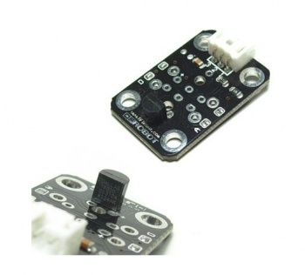](https://www.dfrobot.com/product-164.html)

[18B20 Temperature Sensor](https://www.dfrobot.com/product-164.html)

**Contents**

* [1 Introduction](https://www.dfrobot.com/wiki/index.php/18B20_Temerature_Sensor_(Arduino_Compatible)_(SKU:_DFR0024)#Introduction)
  + [1.1 The Library](https://www.dfrobot.com/wiki/index.php/18B20_Temerature_Sensor_(Arduino_Compatible)_(SKU:_DFR0024)#The_Library)
  + [1.2 Limitations](https://www.dfrobot.com/wiki/index.php/18B20_Temerature_Sensor_(Arduino_Compatible)_(SKU:_DFR0024)#Limitations)
  + [1.3 Benefits](https://www.dfrobot.com/wiki/index.php/18B20_Temerature_Sensor_(Arduino_Compatible)_(SKU:_DFR0024)#Benefits)
* [2 Pin Definition](https://www.dfrobot.com/wiki/index.php/18B20_Temerature_Sensor_(Arduino_Compatible)_(SKU:_DFR0024)#Pin_Definition)
* [3 Connection Diagram](https://www.dfrobot.com/wiki/index.php/18B20_Temerature_Sensor_(Arduino_Compatible)_(SKU:_DFR0024)#Connection_Diagram)
* [4 Sample Code](https://www.dfrobot.com/wiki/index.php/18B20_Temerature_Sensor_(Arduino_Compatible)_(SKU:_DFR0024)#Sample_Code)

**Introduction**

The [**DS18B20 arduino Temperature Sensor**](https://www.dfrobot.com/product-164.html) is a very small thermometer which can be easily hooked into the Arduino MCU through any digital input! It requires very little in the way of additional support, a couple of resistors and some hookup cables and you're set to go.

For more information on the DS18B20 check out [[Maxim-IC](http://www.maxim-ic.com/quick_view2.cfm?qv_pk=2812)].

**The Library**

This library is derived from some good work by the Arduino community. This library is, for the most part, purely a refactor version of the existing library. I found the original to be somewhat of a pain to implement and, like most Arduino libraries, code-seperation sucks.

The intention of this Library is to build on Jim Studt work and make it quick and easy for beginners to get started.

**Limitations**

* The One-Wire library has a nasty look-up table for some associated commands. It isn't directly related to this library but it may cause some problems.

**Benefits**

* Simple and easy to use
* No software limitation to the number of devices you may use

**Pin Definition**

Temperature Sensor pin definition :

1. Input
2. Power
3. GND

[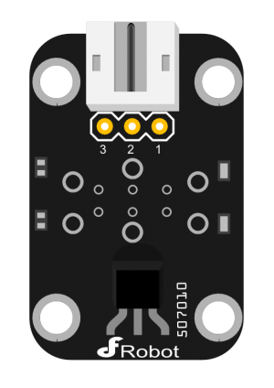](https://www.dfrobot.com/wiki/index.php/File:18B20_Temerature_Sensor.png)

digital input module

**Connection Diagram**

[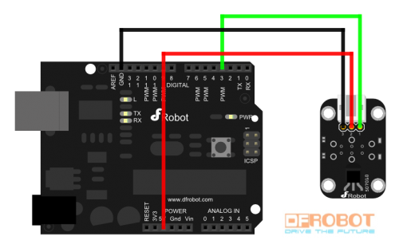](https://www.dfrobot.com/wiki/index.php/File:18B20_Temerature_Sensor_connection_diagram.png)

Digital module connection diagram

**Sample Code**

#include <OneWire.h>

int DS18S20_Pin = 2; //DS18S20 Signal pin on digital 2

//Temperature chip i/o

OneWire ds(DS18S20_Pin); // on digital pin 2

void setup(void) {

Serial.begin(9600);

}

void loop(void) {

float temperature = getTemp();

Serial.println(temperature);

delay(100); //just here to slow down the output so it is easier to read

}

float getTemp(){

//returns the temperature from one DS18S20 in DEG Celsius

byte data[12];

byte addr[8];

if ( !ds.search(addr)) {

//no more sensors on chain, reset search

ds.reset_search();

return -1000;

}

if ( OneWire::crc8( addr, 7) != addr[7]) {

Serial.println("CRC is not valid!");

return -1000;

}

if ( addr[0] != 0x10 && addr[0] != 0x28) {

Serial.print("Device is not recognized");

return -1000;

}

ds.reset();

ds.select(addr);

ds.write(0x44,1); // start conversion, with parasite power on at the end

byte present = ds.reset();

ds.select(addr);

ds.write(0xBE); // Read Scratchpad

for (int i = 0; i < 9; i++) { // we need 9 bytes

data[i] = ds.read();

}

ds.reset_search();

byte MSB = data[1];

byte LSB = data[0];

float tempRead = ((MSB << 8) | LSB); //using two's compliment

float TemperatureSum = tempRead / 16;

return TemperatureSum;

}